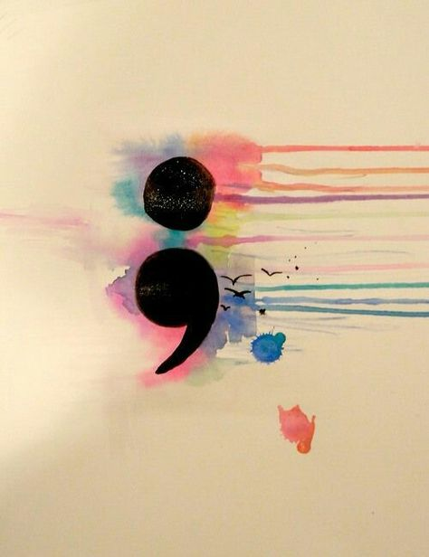

Your story isn’t over….

Suicide Awareness and Prevention

